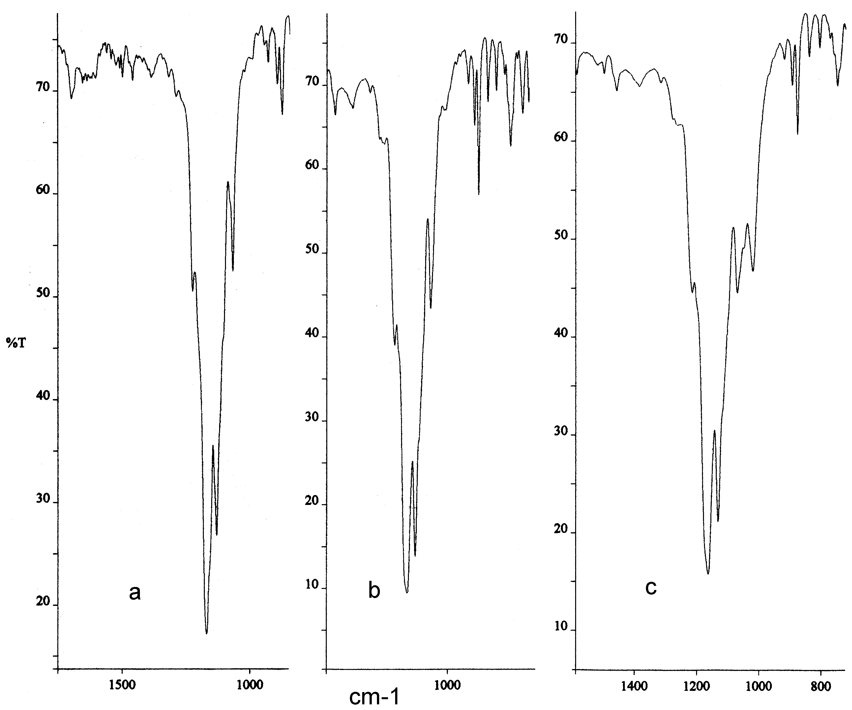
Figs. S1a,b,c IR spectra (KBr) for C₆₀F₃₅OH isomers 1, 2, and C₆₀F₃₆O, respectively

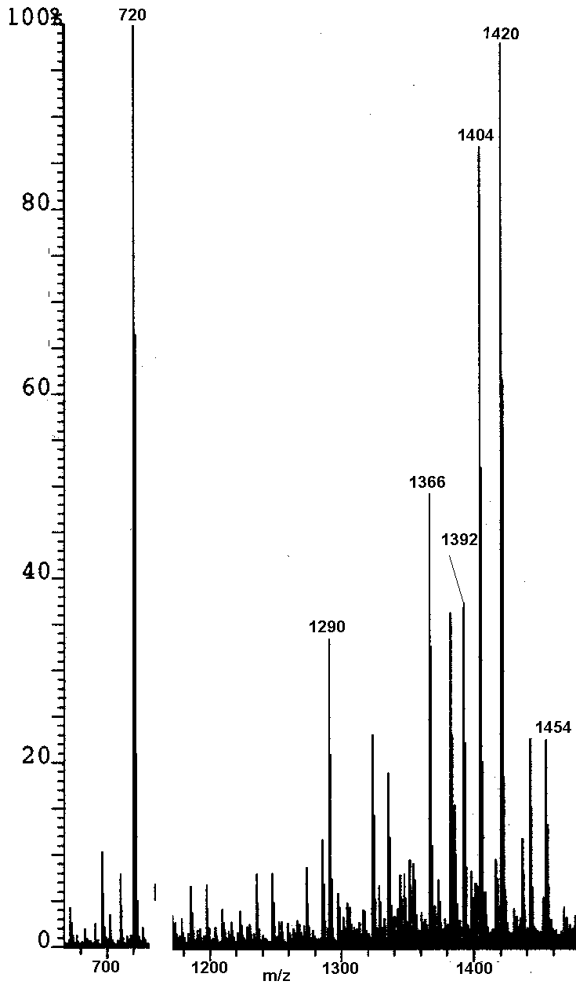

Fig. S2 EI mass spectrum of the sample mixture eluting at 15 min (heptane)
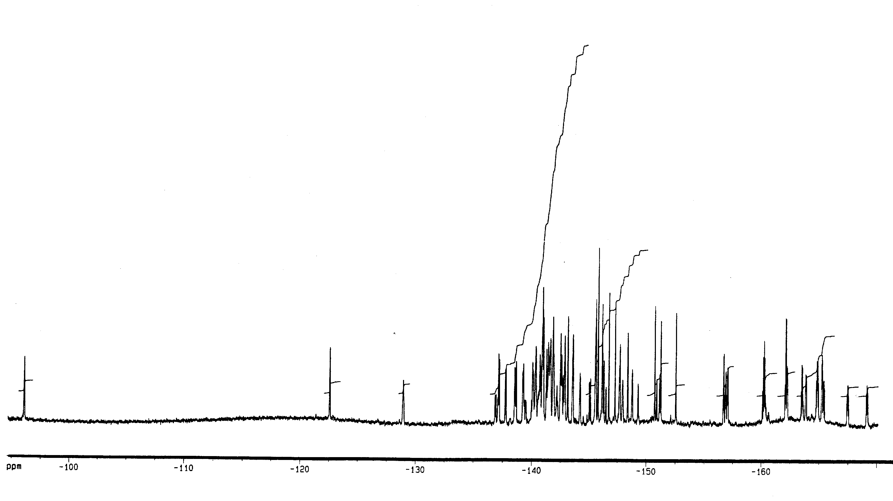
Fig. S3 ¹⁹F NMR spectrum of the sample mixture eluting at 15 min (heptane)

